|  |  |  |  |  |  |  |  |  |  |
| --- | --- | --- | --- | --- | --- | --- | --- | --- | --- |
| **SCHOOL OF COMPUTER SCIENCE AND ARTIFICIAL INTELLIGENCE** | | | | | **DEPARTMENT OF COMPUTER SCIENCE ENGINEERING** | | | | |
| **Program Name:** B. Tech | | | | **Assignment Type: Lab** | | | **Academic Year:**2025-2026 | | |
| **Course Coordinator Name** | | | | Dr. Rishabh Mittal | | | | | |
| **Instructor(s) Name** | | | | |  | | --- | | Mr. S Naresh Kumar | | Ms. B. Swathi | | Dr. Sasanko Shekhar Gantayat | | Mr. Md Sallauddin | | Dr. Mathivanan | | Mr. Y Srikanth | | Ms. N Shilpa | | Dr. Rishabh Mittal (Coordinator) | | Dr. R. Prashant Kumar | | Mr. Ankushavali MD | | Mr. B Viswanath | | Ms. Sujitha Reddy | | Ms. A. Anitha | | Ms. M.Madhuri | | Ms. Katherashala Swetha | | Ms. Velpula sumalatha | | Mr. Bingi Raju | | | | | | |
| **CourseCode** | | | 23CS002PC304 | **Course Title** | | AI Assisted Coding | | | |
| **Year/Sem** | | | III/II | **Regulation** | | R23 | | | |
| **Date and Day**  **of Assignment** | | | **Week1 – Wednesday** | **Time(s)** | | 23CSBTB01 To 23CSBTB52 | | | |
| **Duration** | | | 2 Hours | **Applicable to**  **Batches** | | All batches | | | |
| **Assignment Number:1.3**(Present assignment number)/**24**(Total number of assignments) | | | | | | | | | |
|  | | | | | | | | | |
|  | **Q.No.** | **Question** | | | | | | ***Expected Time***  ***to complete*** |  |
|  | 1 | Lab 2: Exploring Additional AI Coding Tools beyond Copilot – Gemini (Colab) and Cursor AI  **Lab Objectives:**   * To explore and evaluate the functionality of Google Gemini for AI-assisted coding within Google Colab. * To understand and use Cursor AI for code generation, explanation, and refactoring. * To compare outputs and usability between Gemini, GitHub Copilot, and Cursor AI. * To perform code optimization and documentation using AI tools.   **Lab Outcomes (LOs):**  After completing this lab, students will be able to:   * Generate Python code using Google Gemini in Google Colab. * Analyze the effectiveness of code explanations and suggestions by Gemini. * Set up and use Cursor AI for AI-powered coding assistance. * Evaluate and refactor code using Cursor AI features. * Compare AI tool behavior and code quality across different platforms.   **Task 1: Refactoring Odd/Even Logic (List Version)**   * **Scenario:** You are improving legacy code. * **Task:** Write a program to calculate the sum of odd and even numbers in a list, then refactor it using AI. * **Expected Output:** * Original and improved code   **Task 2: Area Calculation Explanation**   * **Scenario:** You are onboarding a junior developer. * **Task:** Ask Gemini to explain a function that calculates the area of different shapes. * **Expected Output:**   + Code   + Explanation   **Task 3: Prompt Sensitivity Experiment**   * **Scenario:** You are testing how AI responds to different prompts. * **Task:** Use Cursor AI with different prompts for the same problem and observe code changes. * **Expected Output:**   + **Prompt list**   + **Code variations**   **Task 4: Tool Comparison Reflection**   * **Scenario:** You must recommend an AI coding tool. * **Task:** Based on your work in this topic, compare Gemini, Copilot, and Cursor AI for usability and code quality. * **Expected Output:**   Short written reflection  **Note: Report should be submitted as a word document for all tasks in a single document with prompts, comments & code explanation, and output and if required, screenshots.** | | | | | | Week1 - Monday |  |

**Lab 2:**

**Task 1: Refactoring Odd/Even Logic (List Version):**

**Given Prompt:**

Write a Refactoring Odd/Even Logic (List Version) according to the given sceniroYou are improving legacy code the task is toWrite a program to calculate the sum of odd and even numbers in a list, then refactor it using AI. The expected output should be Original and improved code

**Orginal Version of code:**

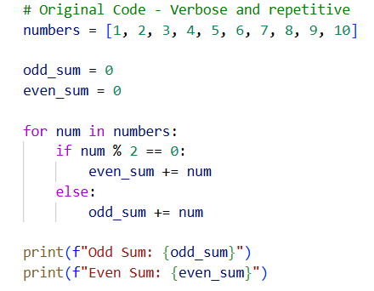

**Sample Input given in the code:**



**Sample output:**



**Refactored Code - Clean and Python:**

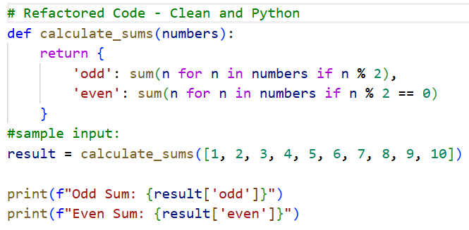

**Sample output:**

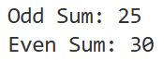

**Task 2: Area Calculation Explanation:**

**Given Prompt:**

Write a Python function called calculate_area that serves as a single entry point for finding the area of a circle, square, rectangle, triangle, and trapezoid. Use a dictionary of lambda functions to handle the logic for each shape type and **kwargs to accept varying inputs, ensuring the entire solution is under 15 lines of code.

**Code:**

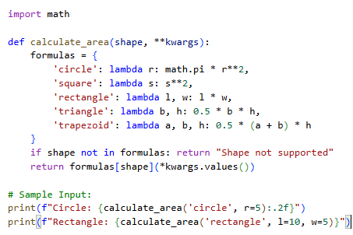

**Sample input:**





**Sample output:**

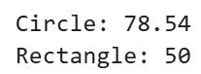

**Explanation:**

This code uses a single function to calculate the area of various shapes by looking them up in a predefined list. Instead of using many "if" statements, it stores the math formulas in a dictionary and picks the right one based on the name you provide. It uses a special Python feature called **kwargs to collect whatever numbers you provide, like radius or height, and plugs them into the formula. This makes the code very short, organized, and easy to update with new shapes.

**Task 3: Prompt Sensitivity Experiment**

**Given Prompt variation:**

1. Write a concise Python function to check if a string and number is a palindrome.

only one code

**code 1**:

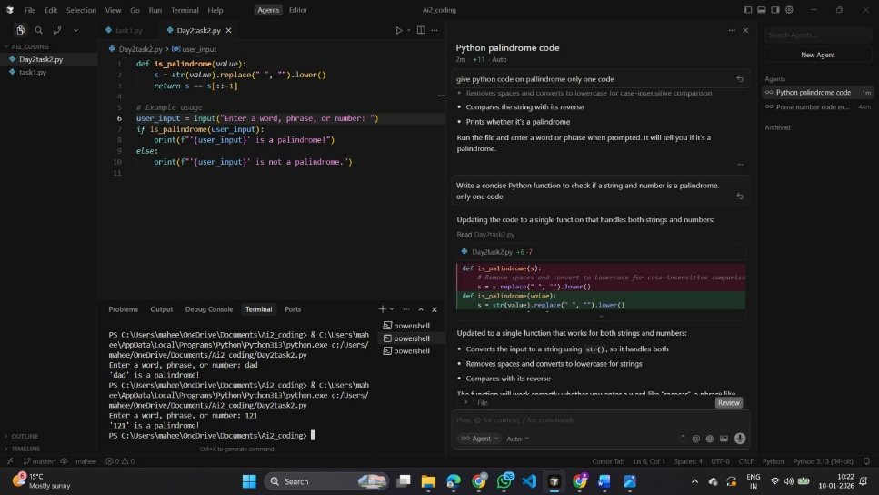

**sample input:**

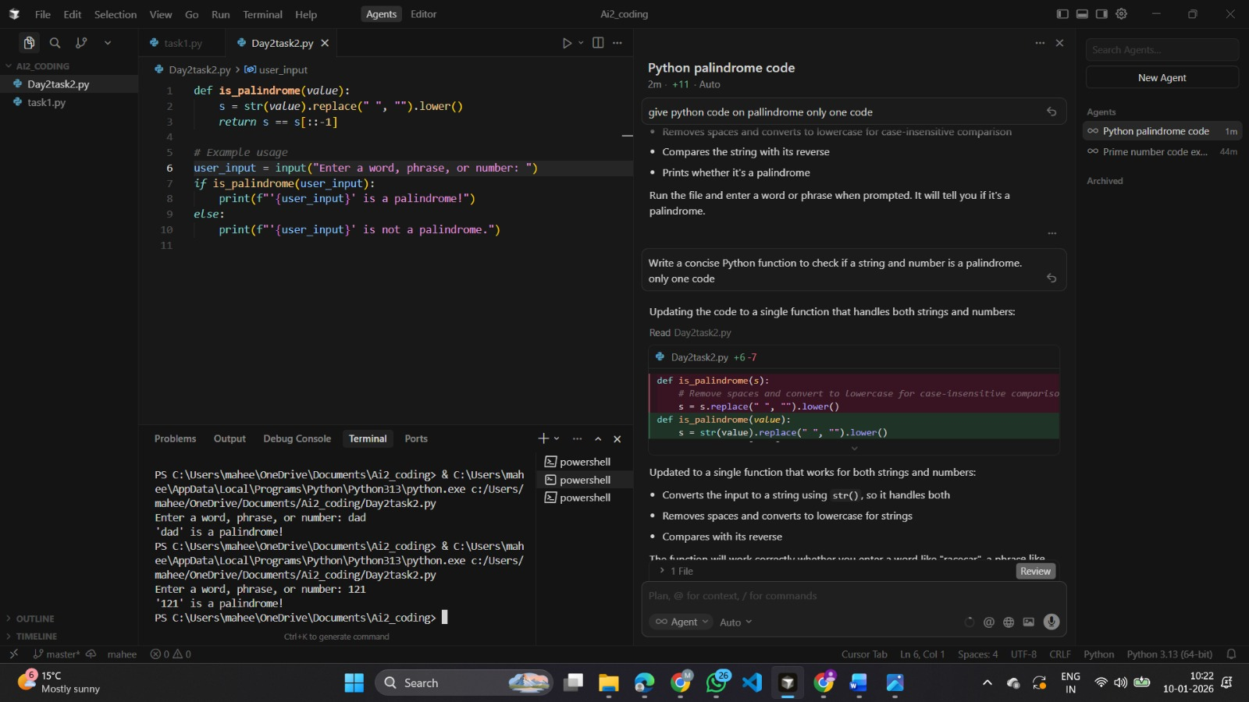

**Sample output:**



1. **give python code on pallindrome only one code**

**Code 2:**

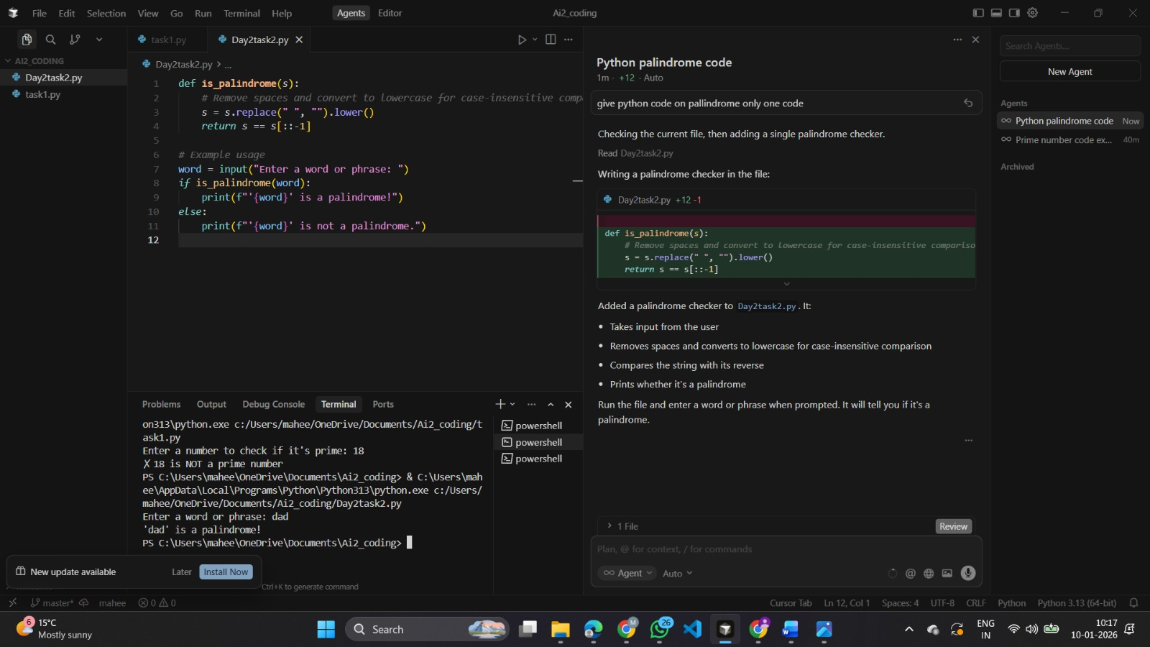

**Simple input:**



**Sample output:**



1. Given a string as input, write a program to determine whether the string is a palindrome or not.

**Code 3:**

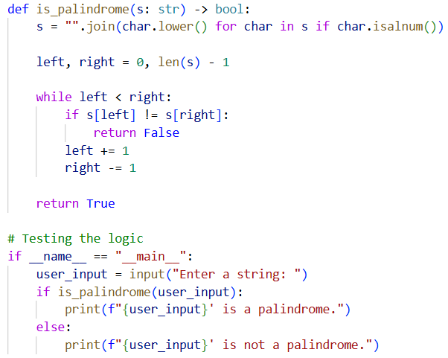

**Sample Input:**



**Sample output:**



**Task 4: Tool Comparison Reflection:**

**Gemini** is a great choice for students, hobbyists, or anyone on a tight budget. Its huge context window and Agent Mode make it ideal for exploring large codebases without paying anything.

**GitHub Copilot** fits best for professional teams that want a reliable, no-friction tool. It works smoothly across IDEs and connects well with GitHub’s security, pull requests, and enterprise workflows.

**Cursor AI** is perfect for power users and startups who care about speed. If you frequently work with large projects or need fast multi-file changes, Cursor delivers productivity that regular code plugins still can’t match.